Fall 2017

Salveet Omns

Welcome to the Fall Edition of the Queritor Quoditianus! If you’re reading this, congratulations. That means you can read, and that is an accomplishment in and of itself. If you can’t read this and all of the characters on this page look like alien symbols to you, then, all the same:

In any case, it’s useful to note that this issue is being published on the eve of the 2017 VJCL Convention. Whether you are presently enjoying the fruits of the convention grounds, or are wallowing in misery on account of your absence from the merriment, this publication is for you. We’ve got articles, particles, and barnacles* all for your amusement.

Without further ado, please enjoy the reading.

-Your Loving Admirer Editor,

Wyatt Joyner
* Sorry, we don’t actually have barnacles
Itinerarium
- Page 1: Introduction
- Page 2: Meet Your Overlords Pt. 1
- Page 3: Meet Your Overlords Pt. 2
- Page 4: J O I N U S… Also, What All We’ve Done This Year!
- Page 5: Classics Are Cool, Yo Pt. 1
- Page 6: Classics Are Cool, Yo Pt. 2
- Page 7: Knee-Slappers, Wisecracks, and Punch-Lines

CONTACT US VIA EMAIL (OFFICER BIO PAGE) OR SOCIAL MEDIA

MEET YOUR OVERLORDS

VSCL President
The Crown Clown
Name: Eliott Rebello
Elliott Rebello is a senior at the University of Maryland, majoring in Biology and Classics. He enjoys short walks on the beach at sunrise and abhors sunsets. He’s a man of few words, all of which happen frequently. His favorite words are: ‘Give’, ‘Me’, My’, and ‘Sandwich’ [In no particular order]. Oftentimes he can be heard on the radio squealing conspiracy theories, all of which are novel and have yet to be debunked. He looks forward to be free of the bonds of the VSCL™ (Vastly Supreme Crayon Logistics).
Email: president.vscl@gmail.com

VSCL Vice President
The Snazziest Clown in Town
Name: Grace McIntire
Grace McIntire is an undergraduate at Randolph-Macon College majoring in Latin and Greek and minoring in History, Secondary Education, and Women’s Studies. As VSCL Vice President she has organized social events for SCL including a trip to the National Zoo, minigolfing, and a Certamen for SCLers. She will also be auditioning JCLers and writing skits at 3am Sunday night for That's Entertainment! Her other duties include fun-draising, making baskets to raffle for scholarships, reminding Elliott of things, and regaling the board with punderful jokes.
Email: vicepres.vscl@gmail.com

VSCL Secretary-Treasurer
The Clown Who’s Not Messing Around
Name: Jaclyn Lund
​ Jaclyn Lund attends the University of Virginia, and she will be graduating in December with her BA in Classics and Psychology. She has served as the Secretary/Treasurer for two years, choosing to simply run for the office and spare Elliott the bloodbath that would have ensued had she run for President. She is also President if the UVA Classics Club. The Secretary/Treasurer is responsible for maintaining the minutes of board meetings and managing the finances. Over the last two years of my office, we have taken payments digital, completely overhauled our organizational scheme, and worked to update the VSCL’s structure as a whole. I leave my successor with a neater binder than came to me (Thanks, Elliott) and a lot of loose change. ​
Email: treasurer.vscl@gmail.com

MEET YOUR OVERLORDS

VSCL Parliamentarian
The Clown Who Turned His Frown Upside-Down
Name: Ben Hillman
Ben Hillman is a fourth year at the University of Virginia majoring in Physics and minoring in Latin. As the Parliamentarian, he is responsible for administering the elections at state convention, finding nominees for all board positions, keeping the order at all meetings, and maintaining the VSCL constitution and bylaws.
Email: parliamentarian.vscl@gmail.com

VSCL Editor
The Clown Who’s Looking Down at the Ground
Name: Wyatt Joyner
Wyatt Joyner is an undergraduate at the University of Virginia, majoring in Computer Science and Classics. He’s a former VJCL President and current Certamen Chair for the UVa Classics Club. He ‘maintains’ the VSCL website and pushes out these publications when he feels like it. He also attends weekly spoken Latin gatherings and is generally a massive dingus.
Email: editor.vscl@gmail.com

VSCL Member-at-Large
Actual Image of Eugene Delano
Name: Eugene Delano
Eugene Delano works for Stafford County schools and attended the University of Mary Washington where he studied Foreign Affairs. As member-at-large he provides advice to the rest of the board, having served two terms as VSCL Vice President, and takes on any duties assigned by the board.
Email: mal.vscl@gmail.com

JOIN THE SILLY CLOWN LEAGUE

Hey, you! Yeah, you! Do you love convention? Do you like slave labor- I mean community service? Do you want to never grow old and take the Latin I Grammar test until you finally get that perfect score? Well, if you like two of those three options, the Senior Classical League is the perfect place for you! Whether you’re great at Latin or just okay, it doesn’t matter in SCL because you mostly just do the behind the scenes paper pushing of convention! The upside is that you have Stockholm syndrome and love convention and the other captives in SCL more than is logical for people you see once a year. Plus, once you are initiated into SCL, you become omniscient, omnipotent, omnipresent, and indispensible. That should help with that Grammar test! Pro tip: if you like puns, you get ten more indispensible points. Or should I say pundispensible points… yes. Yes, I should. On the realsies though, SCL is such a fun organization that lets you meet other awesome nerdy Classicists (that phrase might be mutually exclusive), so if you’re a high school senior you should come to the SCL Reception from 11-11:30 Sunday night in Exhibit Hall A.

-Grace McIntire, VSCL & NSCL VP

WHAT HAPPENED THIS YEAR?

“What did happen this year?” I hear you ask. Well, for starters, the Virginia SCL had a fantastic showing at NJCL this year, with the marvelous result of our very own Grace McIntire assuming the throne of NSCL Vice-President! Three cheers for Grace and all of our attendees at NJCL!
Next, the VSCL ran a superb kick-off Certamen, earning the highest praise from Riverbend’s esteemed Mark Keith:
This is in no way fabricated. Ask Mark Keith if you don’t believe us.
So, as you can probably tell, it’s been a pretty swell year for the VSCL. We hope that you can join us at the University of Virginia on April 7th for the annual Classics Day Certamen! [Visit VSCL.org for more information]

How to Respond When Karen at the Checkout Asks You What Purpose a Dead Language Serves in the Modern World…
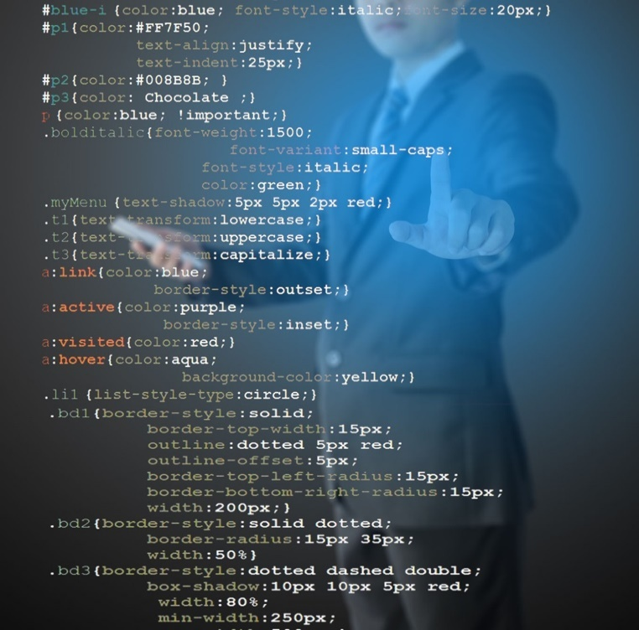
Andrew Orvedahl is an undergraduate in his fourth year at the University of Virginia, where he is double majoring in classics and physics. While his research primarily consists of generating Monte Carlo simulations of collisions at CERN's Large Hadron Collider, he occasionally likes to dabble in joining classics and computer science in side projects

There is a certain tension that all Classics students experience when picking their major. It can sometimes feel that the decision to dive into the past is to abscond from the world of today and to hole up in an eclectic, antiquarian bunker. I, however, had the distinct opportunity to discuss a recent project that bridges the gap between the dusty, old works of yesterday and the shiny, chrome gizmos of tomorrow. Let this serve as a model example for all Classics students struggling to reconcile their affinity for the Ancients with their anxieties over its relevance in the present. Also, go fly a kite, Karen.

What was your undertaking and how did it combine elements from Computer Science and the Classics?
I was taking a class on book III of Caesar's De Bello Civili, and we were asked to write a paper on anything pertaining to Caesar. So, I kludged together a python program to find all of the (regular) first person verbs in a text, and fed it the De Bello Gallico books I-VII, and De Bello Civili books I-III, and generated a list of all of the first person verbs in Caesar, and the chapter in which they appear. Caesar notoriously uses the third person almost exclusively, so when a first person verb appears, it tends to stand out. And it turns out that he uses them almost exclusively in constructions such as “ut ante demonstravimus” (just as we have already shown) (DBG, II.1). I argued that this is evidence that Caesar was writing out reports intended to be disseminated orally.

How does it work?
The program is actually pretty simple, and could be improved a lot if I had the time. It reads an input file, line-by-line, and using regular expressions (a language used for matching patterns in text), picks out all of the words with potential first person endings, it then passes them to a command line version of William Whitaker’s Words installed on my computer, and redirects that to a text file. The program then uses regular expressions to find every time Words finds a (potential) first person verb, and produces a file with a list of each of those words and the line that they appeared in. It isn’t perfect, because it’s finding all of the words that could be first person verbs, not all of the ones that are first person verbs (e.g., eam could be either the feminine accusative singular of is, or it could also be the first person singular, present active subjunctive of eo). If you’ve ever wondered why Google Translate is so awful at Latin, this is just an example of why modeling language with computers is difficult. The computer would require the full context in which the word appears in order to predict its meaning. This program was designed simply to speed up word searches. And it could conceivably be used for other word searches, simply by changing the regular expressions used for matching.

How to Respond When Karen at the Checkout Asks You What Purpose a Dead Language Serves in the Modern World… (Cont.)

What's your next project?
There is a type of program called an artificial neural network, which is modeled after the human brain, and is one of the most promising areas of study in machine learning and artificial intelligence, and provides a possible answer for the problem mentioned above.

The human brain is formed from a web of interconnected neurons, which fire only if they get a strong enough signal from a connected one. We can model this same sort of process on a computer by making a chain of tensors filled with random weights, and multiplying an input tensor (a numerical representation of a picture, a collision of elementary particles, or even a string of text) with the first tensor in the network. We then multiply the output of that operation with the next layer, until we get an output (normally a probability of whatever we are looking for). This is how google image search finds school buses when you search for them.

If you feed the output of this network into it again with new input, it develops a sort of short-term memory. We can then use this to predict the next word or character in a string of text. It may not work, because we have so little text to work with (~7600 characters total), but a professor of mine and I are in the very early stages of a project using this technology to find phonetic patterns in Linear A.

Do you have any suggestions for how others might integrate other areas of study into the Classics or vice versa?
Follow your interests. I got the idea for using a neural network on Linear A while thinking about a problem that came up in my physics research. I thought of the Caesar project because I didn’t want to go through the text word-by-word, and I enjoy programming and welcomed the challenge. Give things a try, and the worst case scenario is that it doesn’t work. People seem to forget far too frequently that the fact that something doesn’t work is still usable data.

Take that, Karen.

DIARIES OF A JCLER: THE PLAGUE
The following writings were recovered by the SCL in the ruins of the 2014 convention.

It was my first convention, and it was the first testing session. I was anxious and excited. I grabbed my tests and took a seat happily on the floor. And that is when it all started…
However, before I begin to deliver this tale, which is so horrific and vile (and, therefore, not for the faint of heart), I’d like to reflect upon the reasons why we partake in such masochism as taking tests for fun. There are no reasons.
Now, with that business brushed aside haphazardly, we may precede to that fateful day: the day the plague began.
I had already collected my tests, and I was eagerly awaiting the start of the session with pencil in hand. I was going to place; I felt it in my bones. But when the SCL President walked up to the microphone and commenced the testing session, as ominous silences scuttled about. Something was coming; I felt it in my bones. Or was that the fact that I was going to place?
Side note: what things are permitted to be felt either in or around bones?
Anyway, the fact of the matter was this: I hadn’t completed question three when patient zero revealed himself. At first, there was nothing worthy of raising alarm, but then another was infected, and another. All of it happened so fast. Before the SCLers could contain it, the mob of JCLers were coughing (some were wailing in pain). Theth plagueth hath cometh, I thought. I really gotta fixth thisth listhp, I wisthpered.
I ran for the door. I even left my test behind.
“You cannot leave until fifteen minutes have passed,” they might have said, but I could not know. Everything was a blur, a flash. The coughing was building louder. I thought I even heard a sneeze.
I was almost to the door. My salvation awaited, but I wasn’t quick enough. I was infected. Infected by this cruel plague. I coughed, and, needless to say, I was sent home at my parent’s expense.

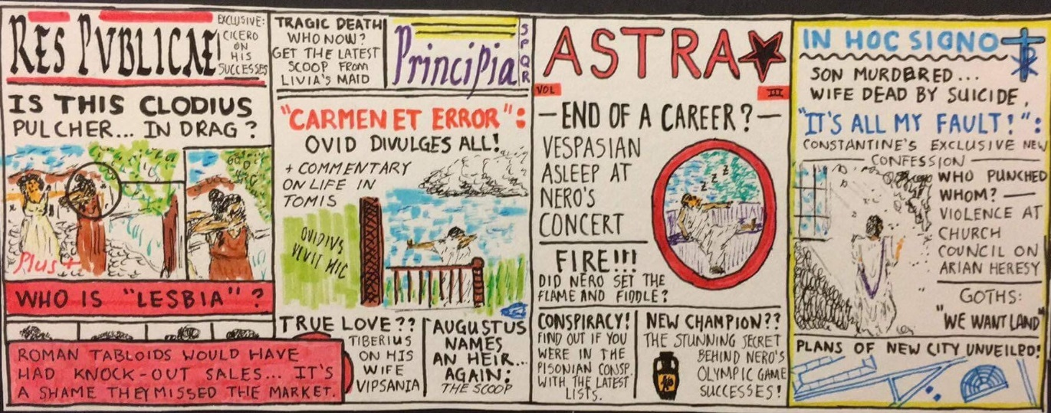

A particular gracious JCLer, Douglas Griffin, has allowed us to use his illustration so that we may maintain the image that this farce of a publication is as developed as a big boy newspaper. All the same, maximas gratias, Douglas!
THANK YOU, YOU BIG DUMMIES, HAVE A FUN
CONVENTION

